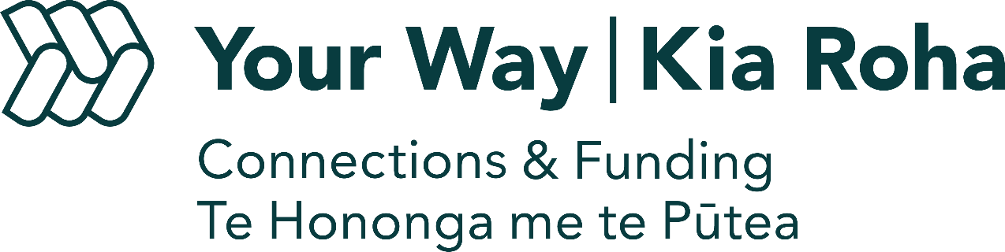

Confirming your disability

Phone: 0800 758 700 or 0508 447 6275
Email: referrals@yourwaykiaroha.nz

Who should use this form?
If it is the first time you’ve worked with Your Way I Kia Roha Connections & Funding team, please ask your doctor or specialist to complete this form to confirm your disability. Please attach it to your Connections & Funding Referral Form. If you have any questions, please contact us using the details at the top of this form.
- Person’s Name and Diagnosis

Full name: | National Health Index Number (NHI):
Disability diagnosis:
Is your / the person’s disability ACC related? Please tick
Yes
No
Does the person live with any other medical, mental health or accident-related conditions? If so, please describe:

- Health Professional Declaration

Full name: | Organisation:
Signature:
Date:

